Practical-3

Responsive UI Design using CSS Grid, Flexbox, and Bootstrap/Tailwind
Problem Definition Design responsive layouts for Home, About, Registration, Dashboard, and
Events pages using CSS Grid and Flexbox. Optional to use CSS
framework such as Bootstrap or Tailwind. Ensure mobile-first
responsiveness.

A.Theory
Q1. How does the layout adapt for mobile, tablet, and desktop screens?
Ans: The layout is responsive and adjusts according to different screen sizes. Elements resize and stack properly on mobile, tablet, and desktop screens.
Q2. Which layout technique is used and why?
Ans: CSS Flexbox is used because it helps arrange and align elements easily and creates a responsive layout.
Q3. Are typography, spacing, colors, and contrast readable?
Ans: Yes. The fonts are clear, spacing is proper, and the colors have good contrast, making the content easy to read.
Q4. Is the framework used consistently without unnecessary inline CSS?
Ans: Yes. The CSS framework and external CSS are used consistently. Unnecessary inline CSS is avoided, keeping the code clean and easy to maintain.

B.implementation
1.home
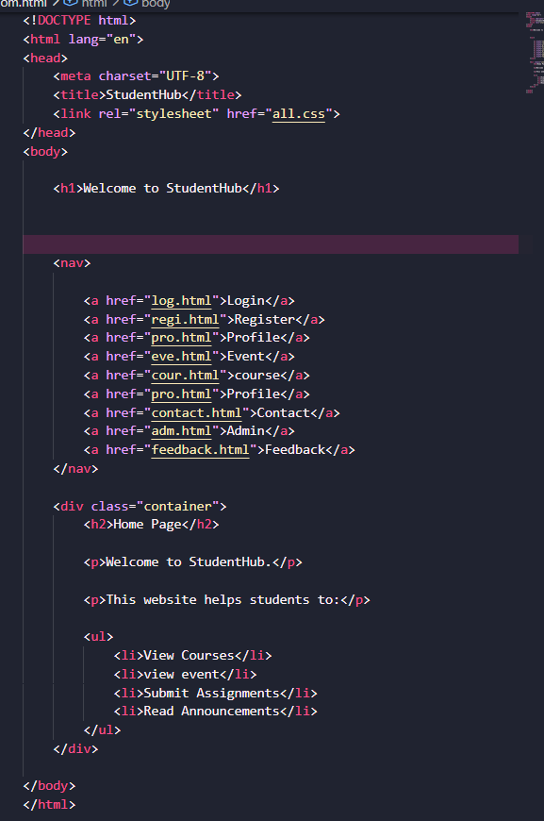
2.login
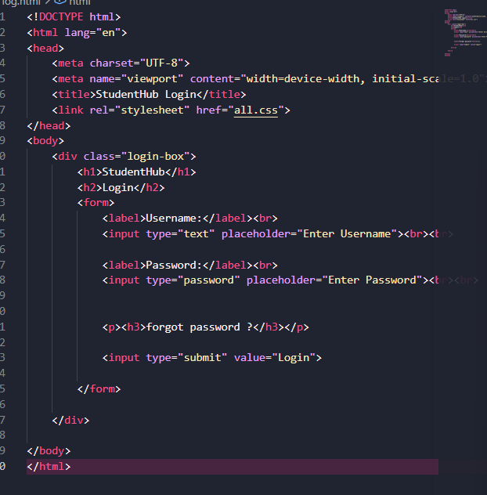
3.registation
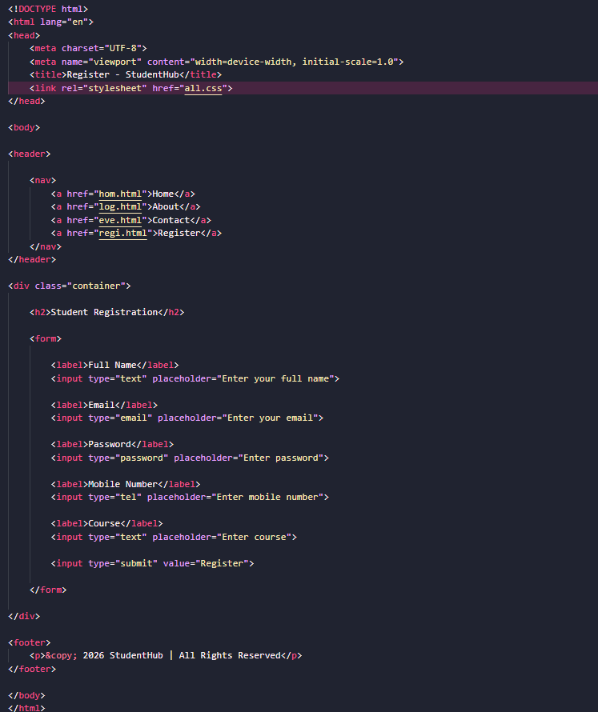
4.event
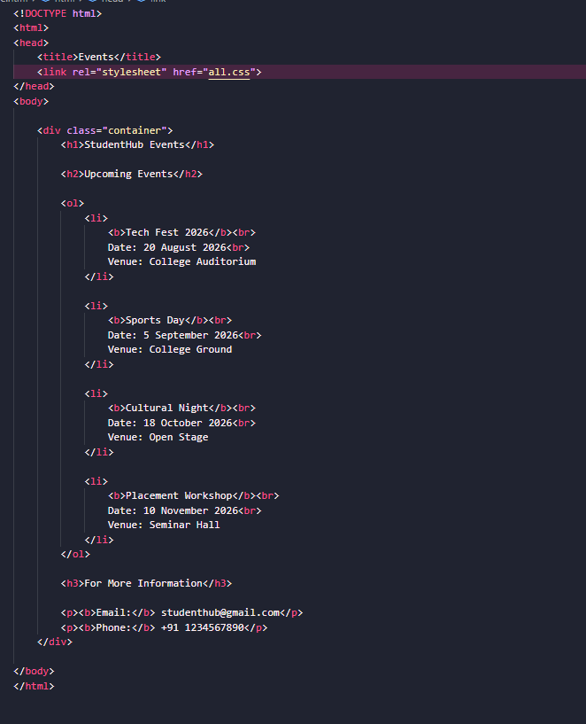
5.feedback
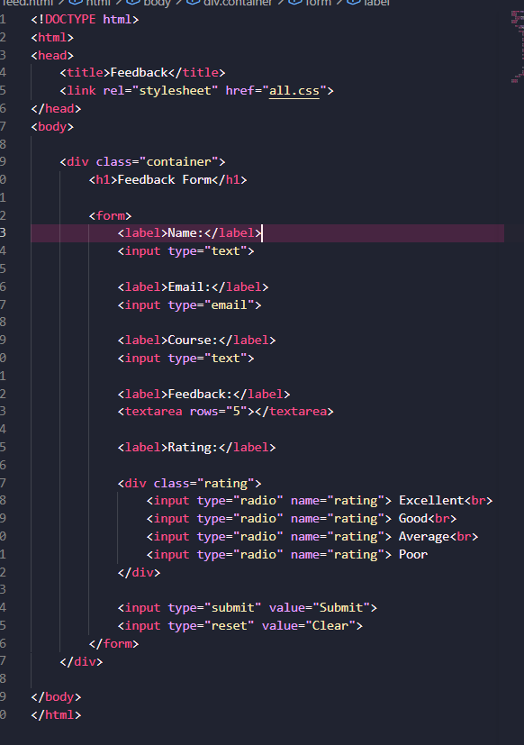
6.profile
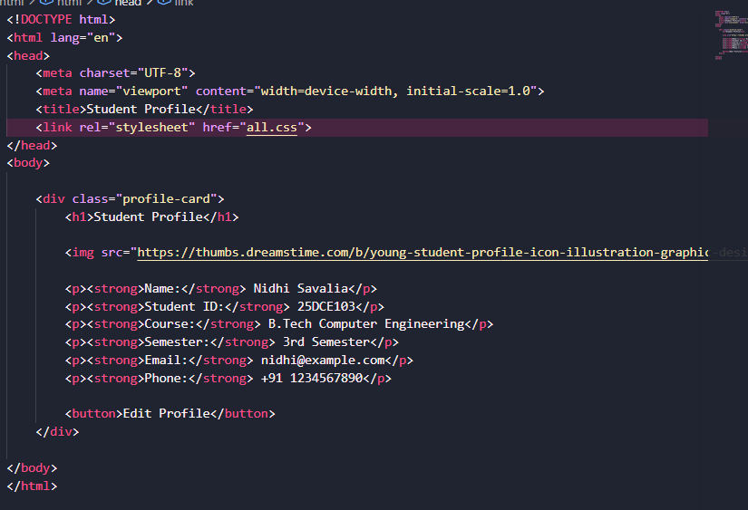
7.Admin
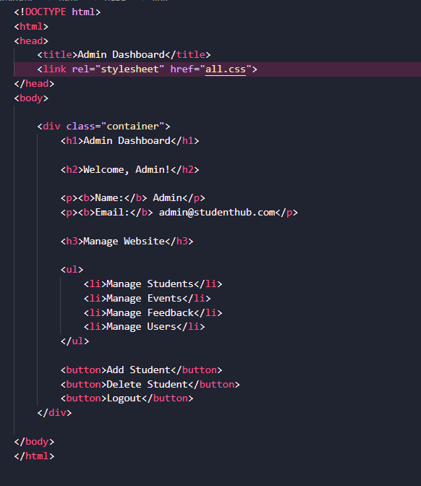
8.course
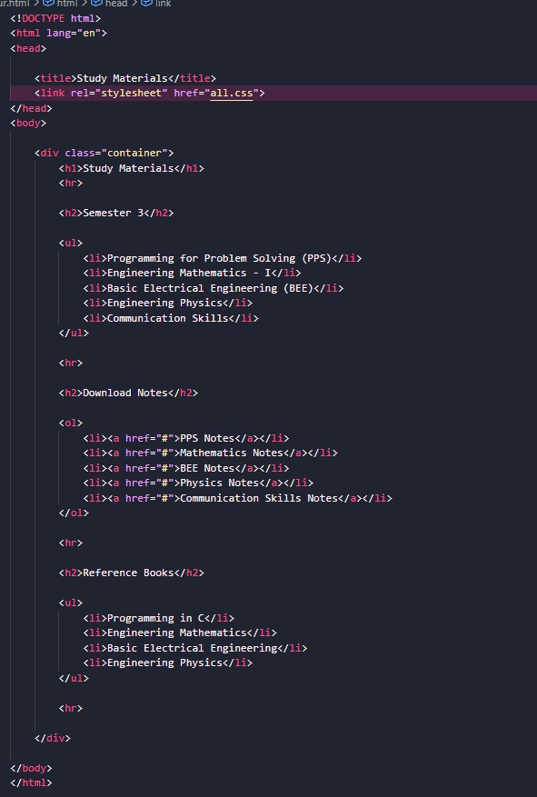
9.contact
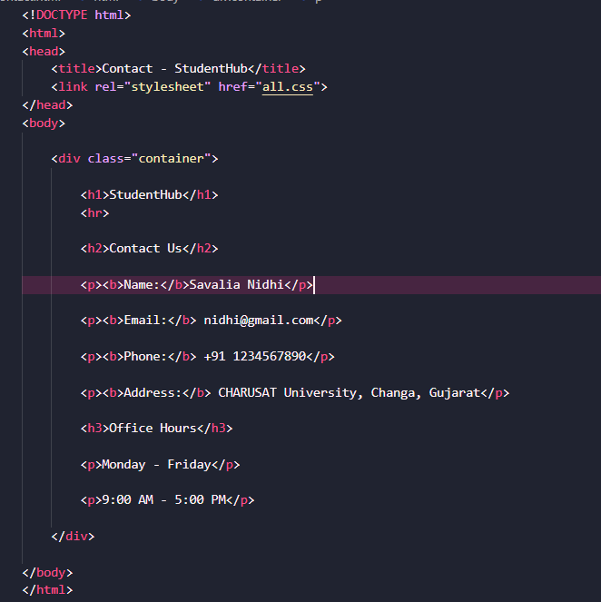
10.about
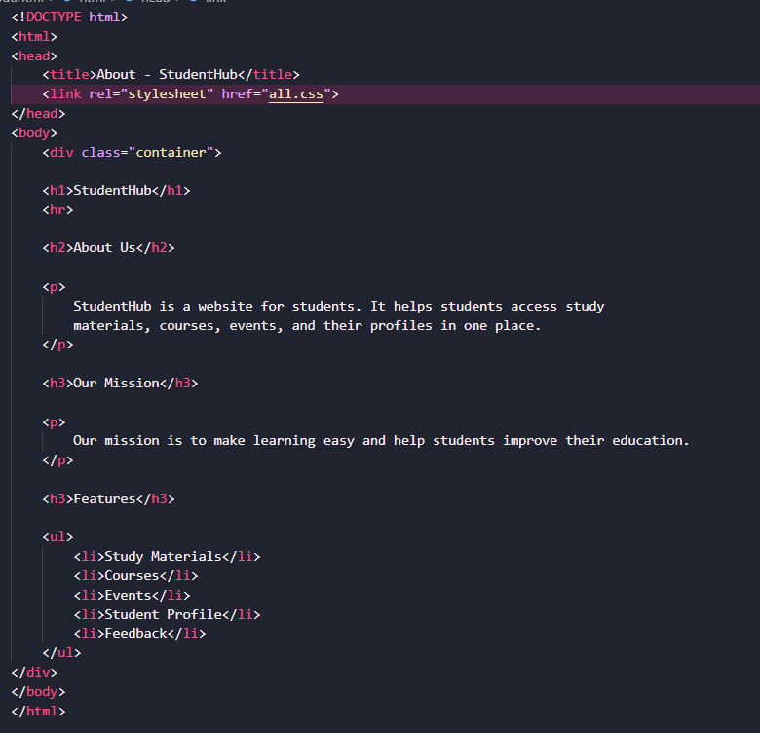
Css code:

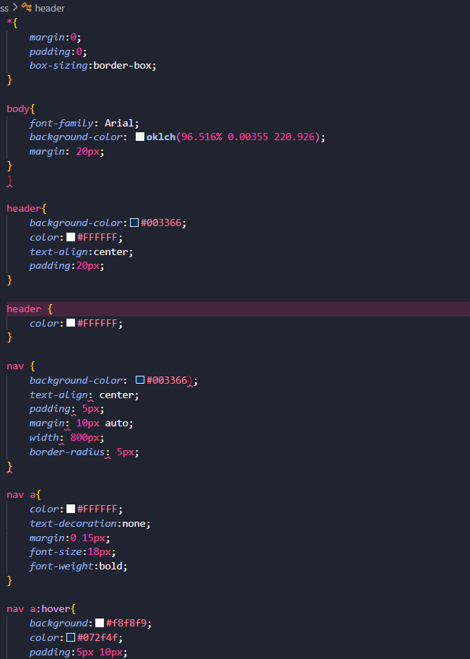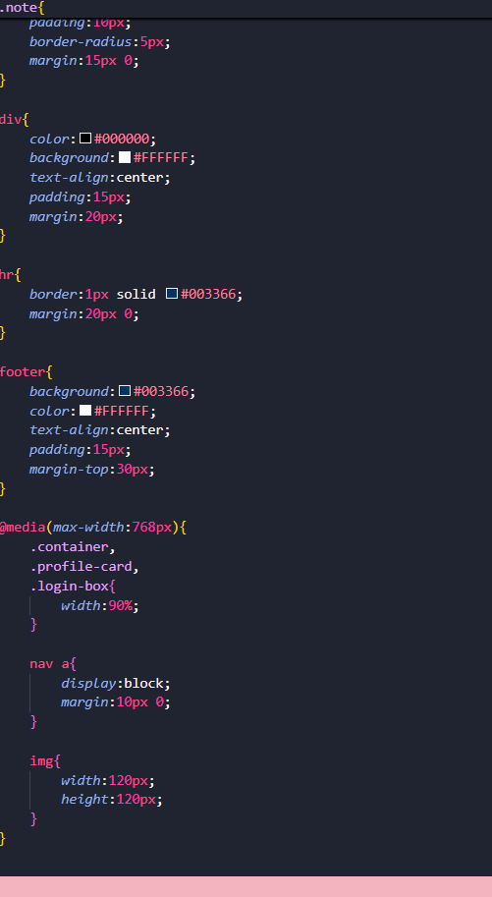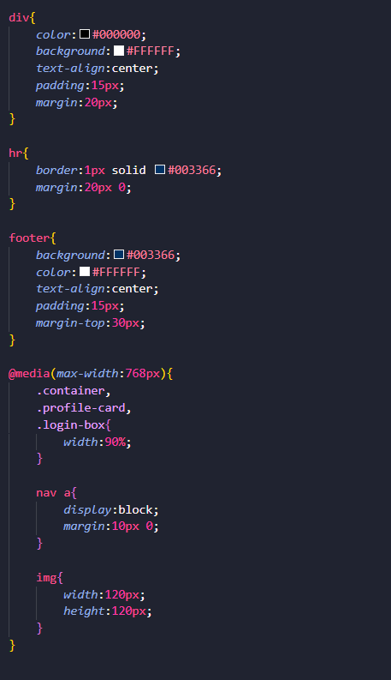

C.Evidence of work
1.home
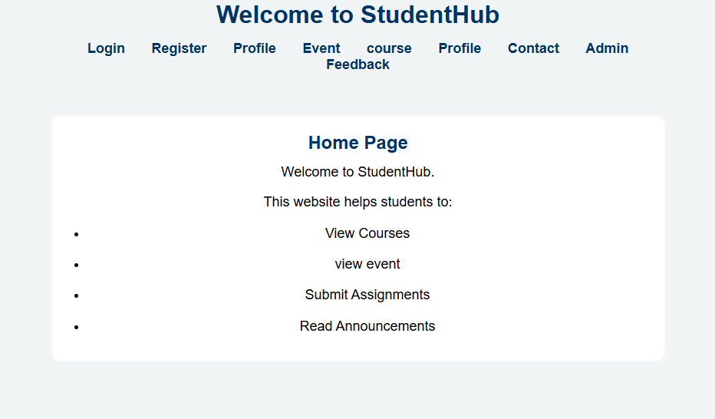
2.login
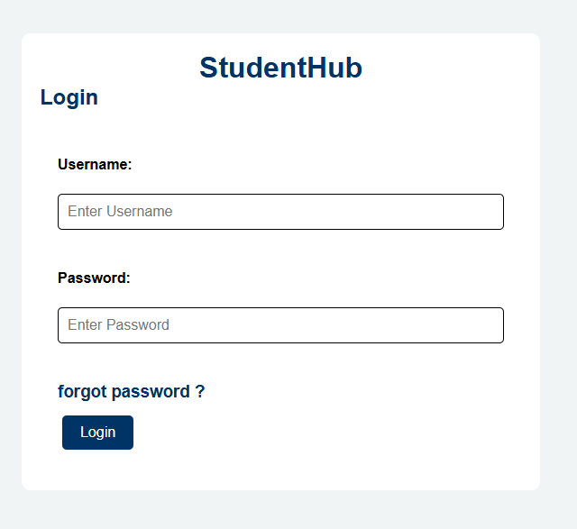
3.register
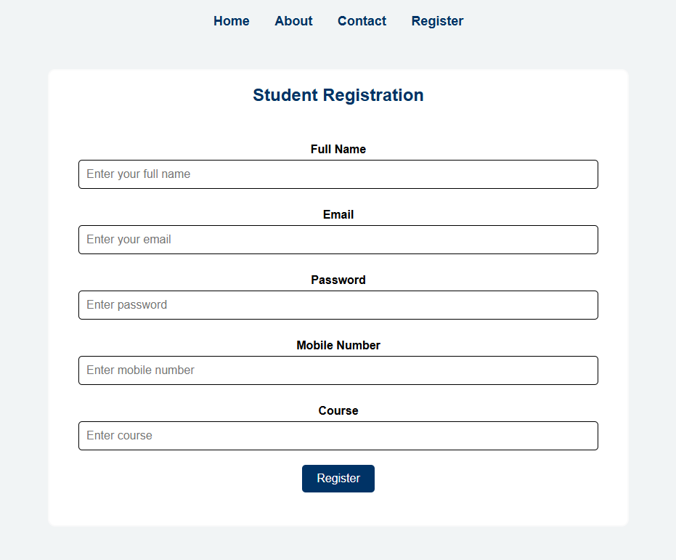

3.event
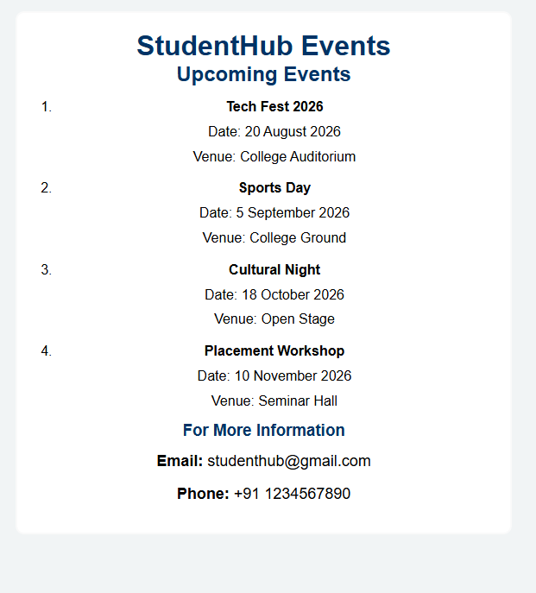
4.feedback:
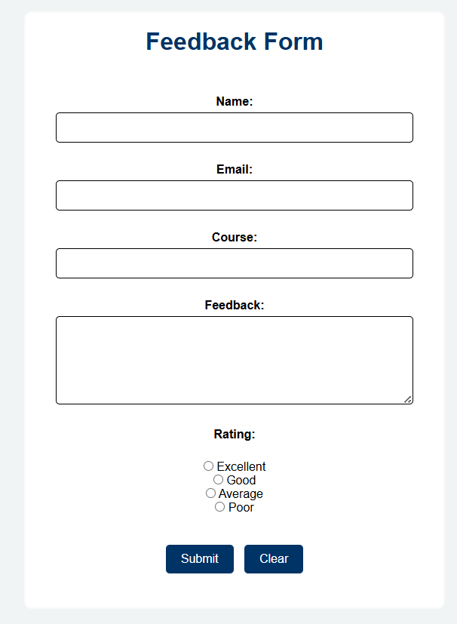

5.profile
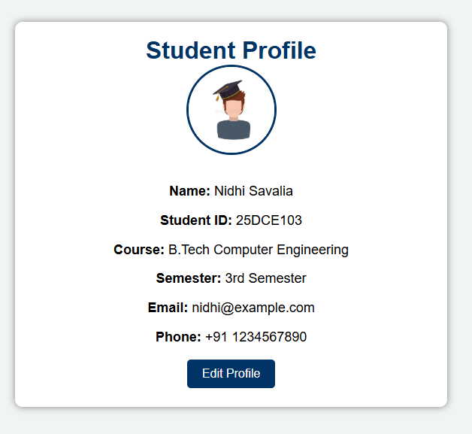
6.admin
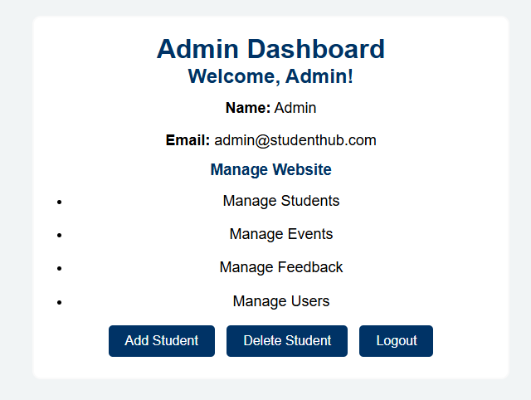
7.course
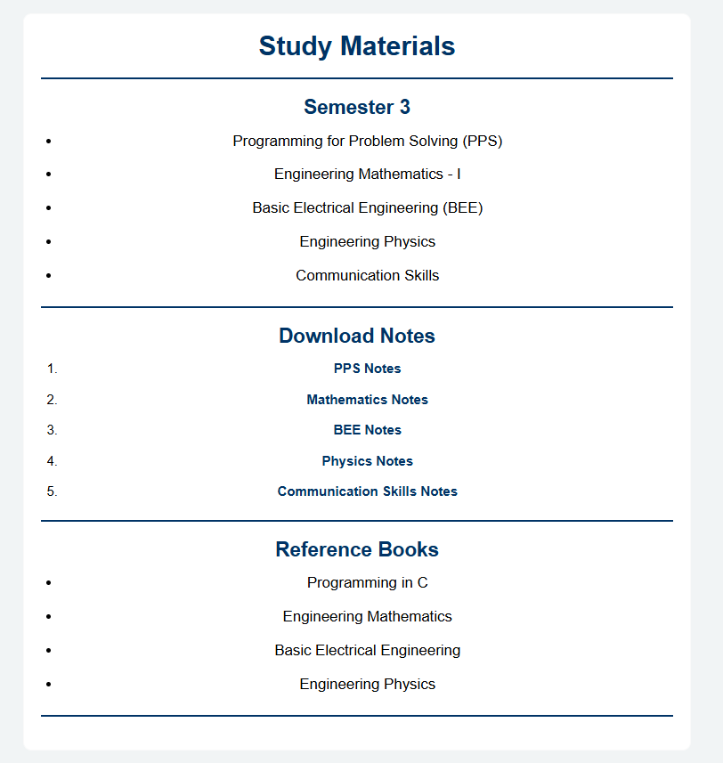
8.admin
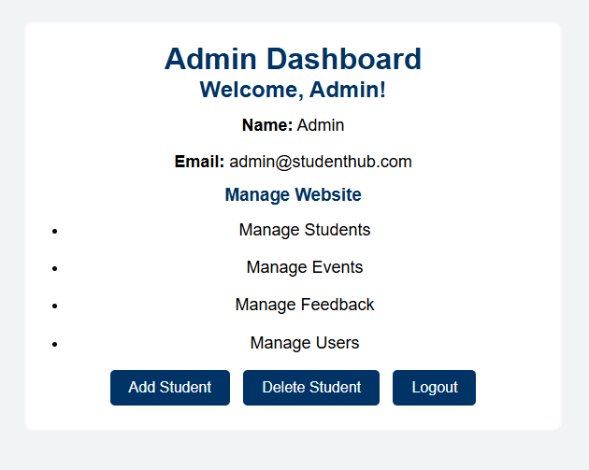
9.contact
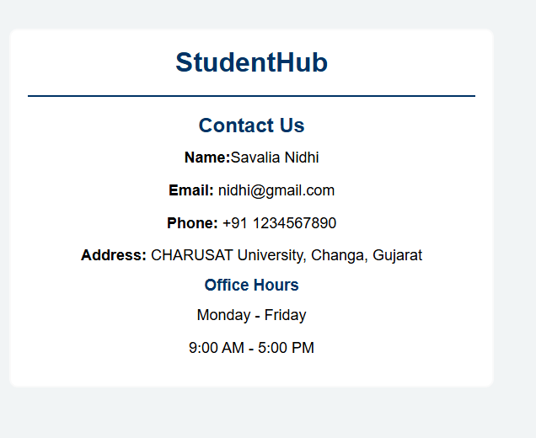
10.about
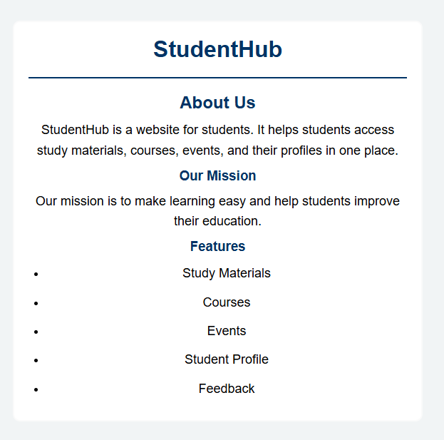
D.GitHub
https://github.com/nidhisavalia/25dce103-web

E.challenges faced:
F.Learning outcome:

Understand the basics of CSS.
Apply colors, fonts, spacing, and backgrounds.
Use CSS selectors and properties.
Create responsive layouts.
Use Flexbox/Grid for page layout.
Design clean and user-friendly web pages.
Use external CSS for consistent styling.

Faculty Remarks:

